**DAILY ONLINE ACTIVITIES SUMMARY**

|  |  |  |  |  |  |  |  |  |
| --- | --- | --- | --- | --- | --- | --- | --- | --- |
| **Date:** | **19-06-2020** | | | | | **Name:** | **Anix Jugal D’Cunha** | |
| **Sem & Sec** | **8 sem , A sec** | | | | | **USN:** | **4AL16CS013** | |
| **Online Test Summary** | | | | | | | | |
| **Subject** | | **BDA** | | | | | | |
| **Max. Marks** | | **30** | | **Score** | | | **24** | |
| **Certification Course Summary** | | | | | | | | |
| **Course** | **JavaScript Beginner's Guide** | | | | | | | |
| **Certificate Provider** | | | **Udemy** | | **Duration** | | | **30 mins** |
| **Coding Challenges** | | | | | | | | |
| **Problem Statement:** Row column position | | | | | | | | |
| **Status: Competed** | | | | | | | | |
| **Uploaded the report in Github** | | | | | **yes** | | | |
| **If yes Repository name** | | | | | **alvas-education-foundation/dcunhaanixjugal** | | | |
| **Uploaded the report in slack** | | | | | **yes** | | | |

Online Test Details: (Attach the snapshot and briefly write the report for the same)

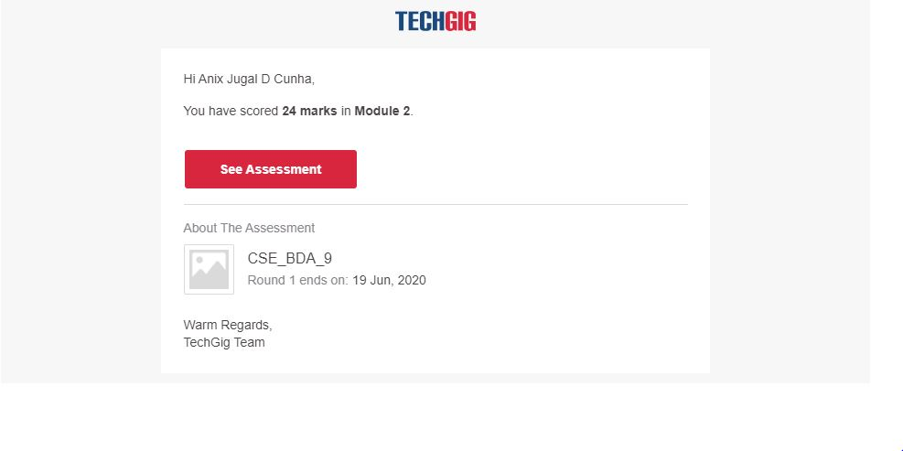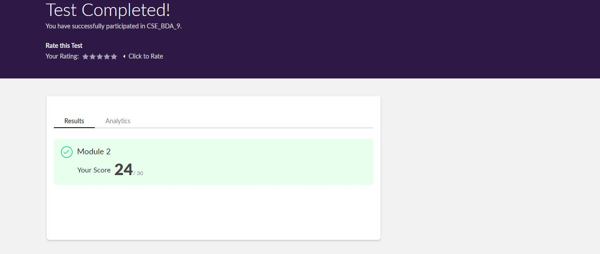

Certification Course Details: (Attach the snapshot and briefly write the report for the same)

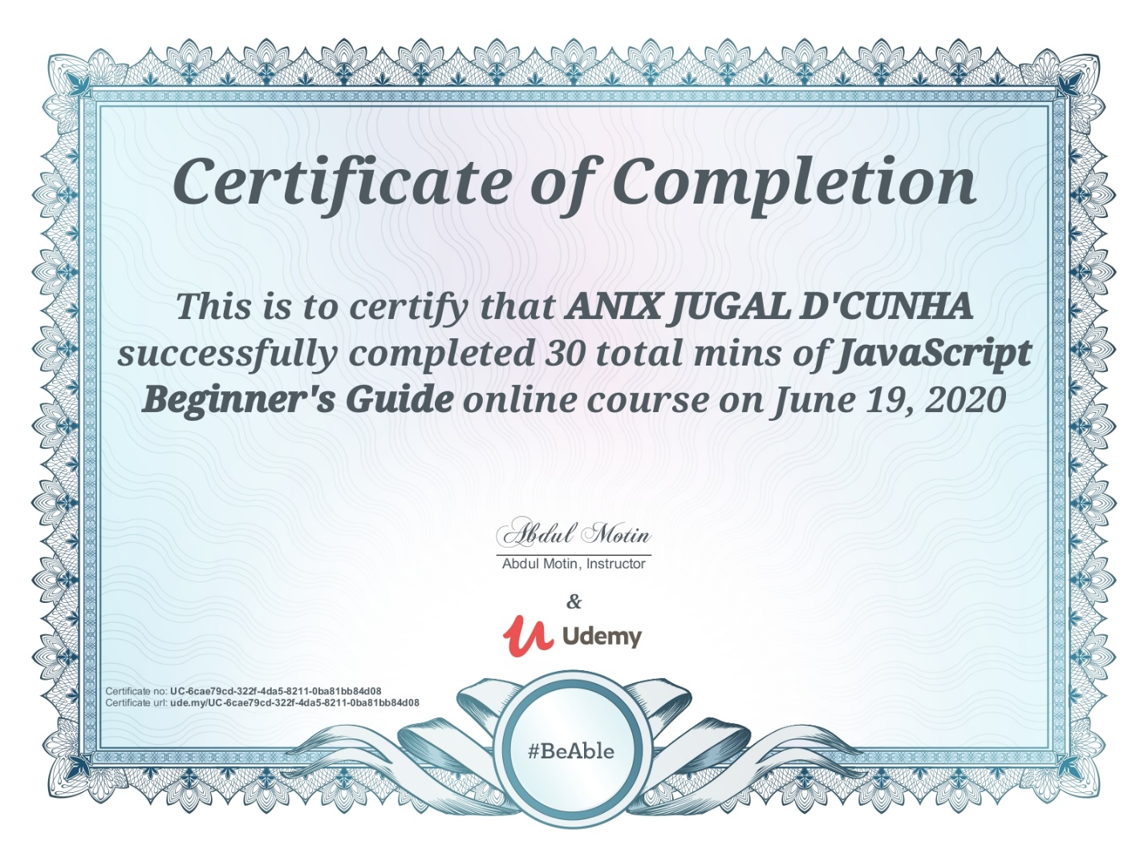

Coding Challenges Details: (Attach the snapshot and briefly write the report for the same)

Program-> Row column position

import java.util.*;

public class abc {

public static void main(String[] args) {

int nums[][] = {{12, 20, 30, 40},

{15, 25, 35, 45},

{24, 29, 39, 51},

{35, 30, 39, 50},

{50, 60, 75, 72}};

​​​

​ int rows = 5;

​ int search_element = 39;​​

int ans[] = Saddleback(nums, rows - 1, 0, search_element);

System.out.println("Position of "+search_element+" in the matrix is ("+ans[0] + "," + ans[1]+")");​​​

}

private static int[] Saddleback(int nums[][], int row, int col, int search_element) {

//numsay to store the row and column of the searched element

int element_pos[] = {-1, -1};

if (row < 0 || col >= nums[row].length) {

return element_pos;

}

if (nums[row][col] == search_element) {

element_pos[0] = row;

element_pos[1] = col;

return element_pos;

}

else if (nums[row][col] > search_element) {

return Saddleback(nums, row - 1, col, search_element);

}

return Saddleback(nums, row, col + 1, search_element);

}

}